Surface-Depression Subtraction

Definition
# Source: AI Source: Provided by: [Data Path: Persons Table -> ID Column: 1, Name_En Column: Motasem Essam] -> From: [ChatGPT] on [7/25/2026]
Surface-Depression Subtraction is a method of forming a composite solid by removing material from a portion of an existing solid's outer surface to create a depression, indentation, or recessed region.
Unlike a through-hole, the removed material does not create a passage through the solid. Unlike a conventional blind hole, a surface depression is not necessarily narrow or deep; it can be a wide, shallow, stepped, or irregular recessed region.
The resulting solid has a modified outer surface containing one or more recessed areas.

Simple Definition
# Source: AI Source: Provided by: [Data Path: Persons Table -> ID Column: 1, Name_En Column: Motasem Essam] -> From: [ChatGPT] on [7/25/2026]
Surface-depression subtraction means removing material from the outside surface of a solid to create a recessed or sunken area without passing completely through the solid.

Geometric Representation
# Source: AI Source: Provided by: [Data Path: Persons Table -> ID Column: 1, Name_En Column: Motasem Essam] -> From: [ChatGPT] on [7/25/2026]
A surface depression can be created in different ways depending on the shape, depth, and arrangement of the removed region.
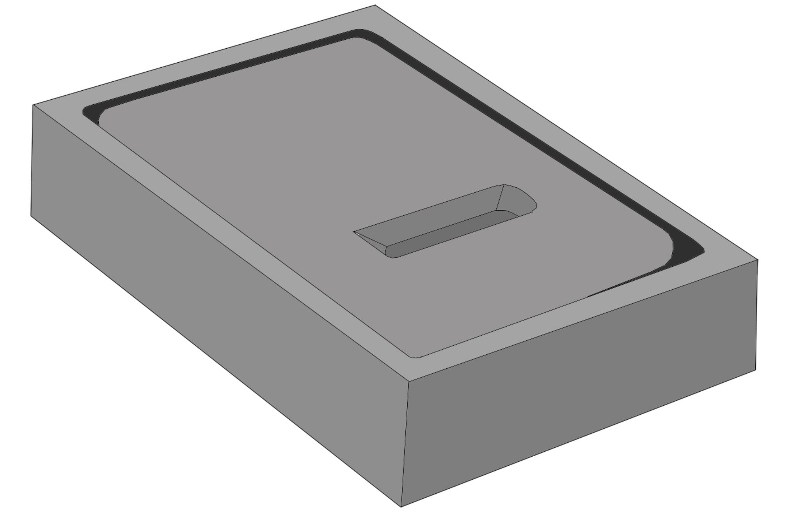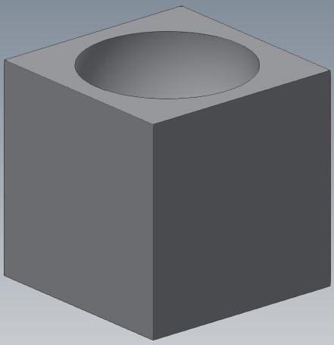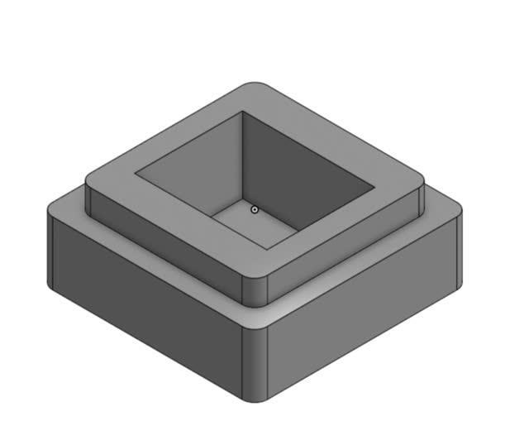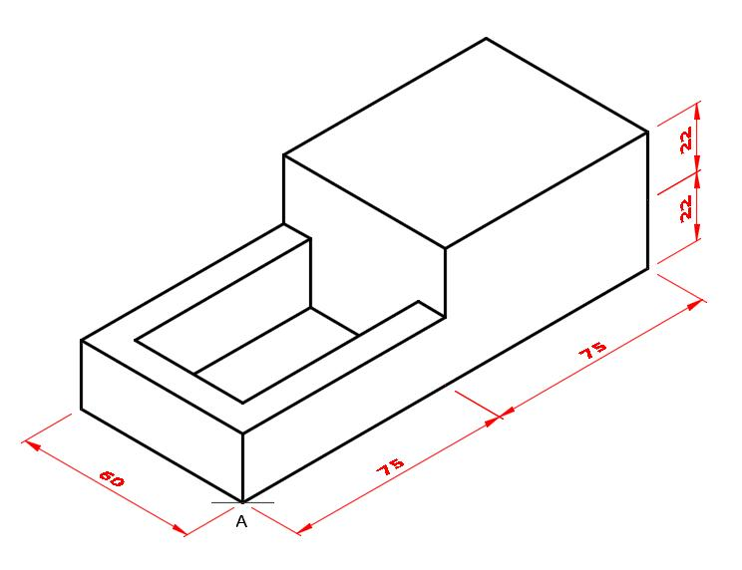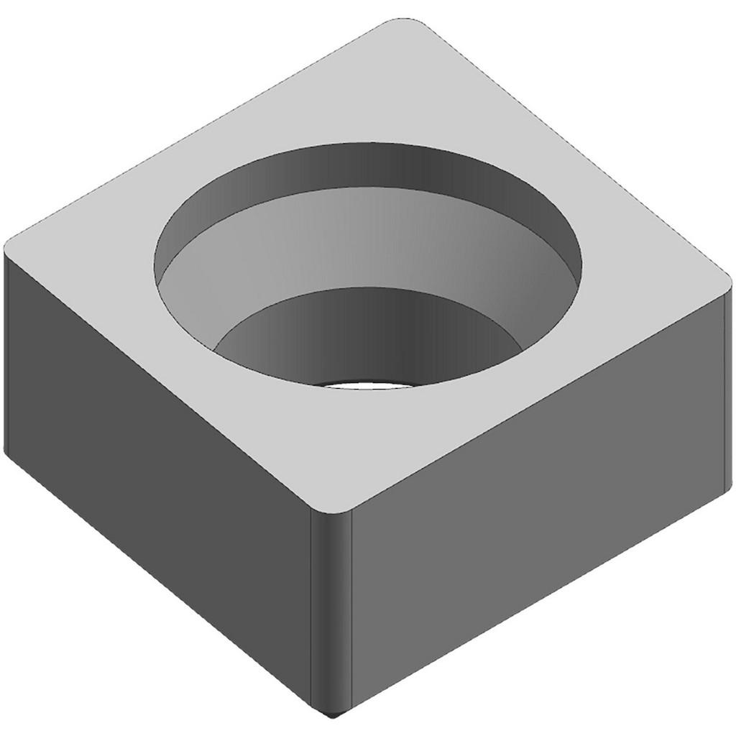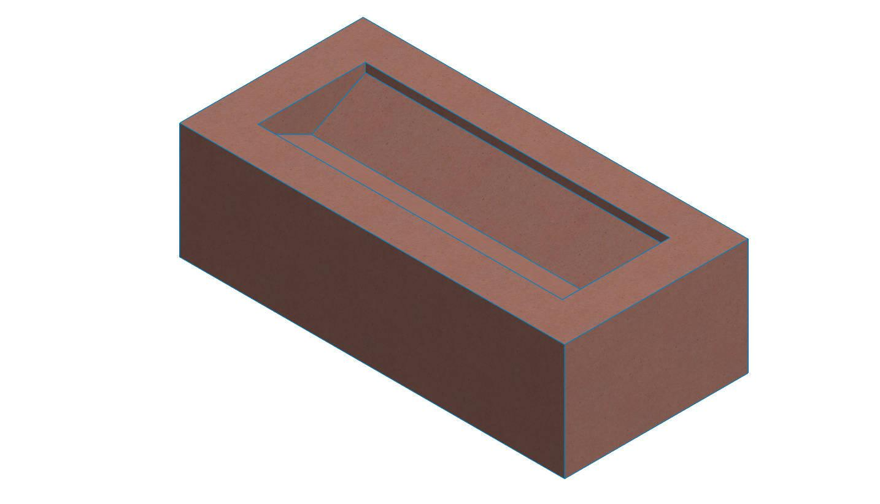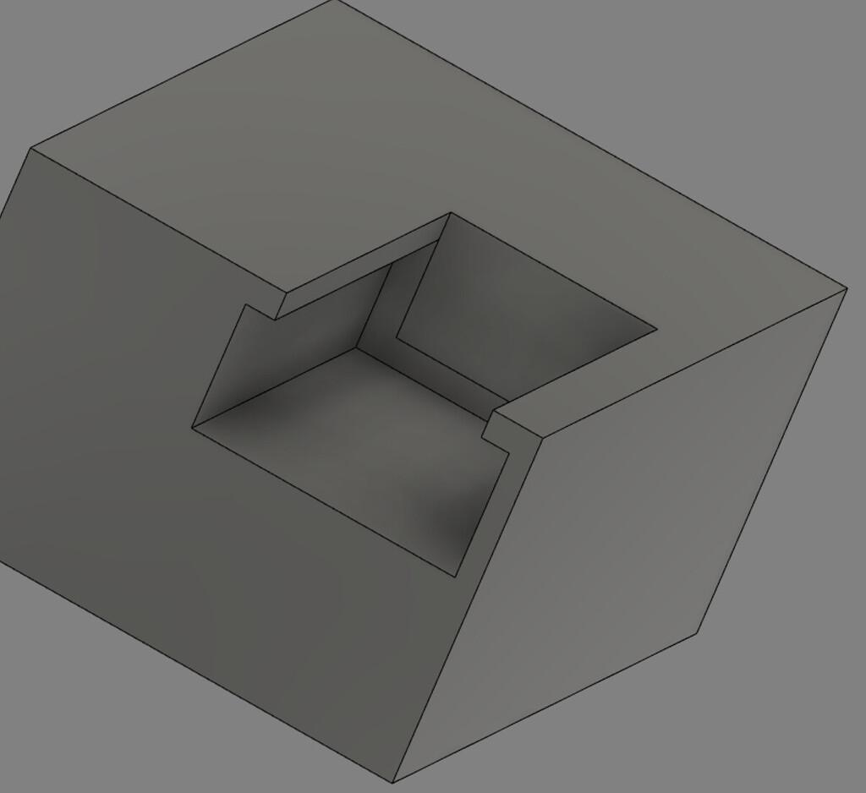
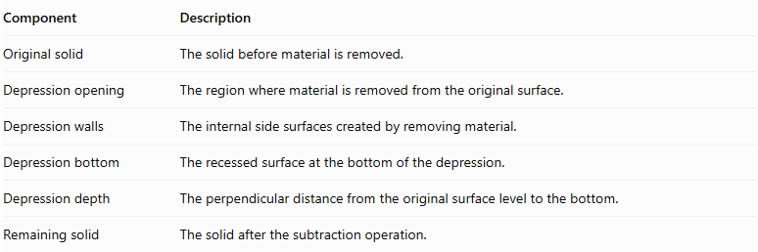
Component | Description
Original solid | The solid before material is removed.
Depression opening | The region where material is removed from the original surface.
Depression walls | The internal side surfaces created by removing material.
Depression bottom | The recessed surface at the bottom of the depression.
Depression depth | The perpendicular distance from the original surface level to the bottom.
Remaining solid | The solid after the subtraction operation.

Main Classification
# Source: AI Source: Provided by: [Data Path: Persons Table -> ID Column: 1, Name_En Column: Motasem Essam] -> From: [ChatGPT] on [7/25/2026]
Surface-depression subtraction can be classified according to the geometric shape of the removed region.

Rectangular Surface-Depression Subtraction
# Source: AI Source: Provided by: [Data Path: Persons Table -> ID Column: 1, Name_En Column: Motasem Essam] -> From: [ChatGPT] on [7/25/2026]
Material is removed from a solid to create a rectangular recessed region.
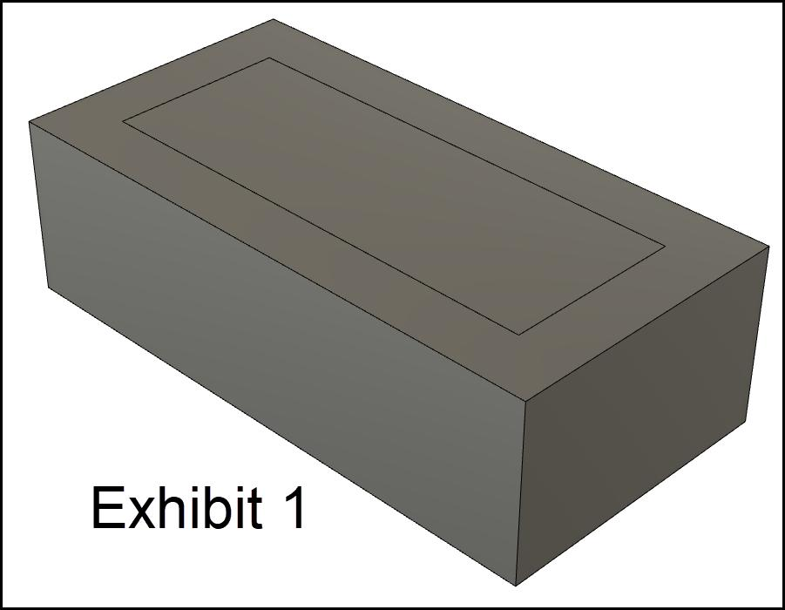
- Opening: Rectangular.
- Walls: Usually four rectangular walls.
- Bottom: Rectangular.
- Common example: A rectangular pocket in a rectangular prism.

Square Surface-Depression Subtraction
# Source: AI Source: Provided by: [Data Path: Persons Table -> ID Column: 1, Name_En Column: Motasem Essam] -> From: [ChatGPT] on [7/25/2026]
Material is removed to create a square-shaped depression.
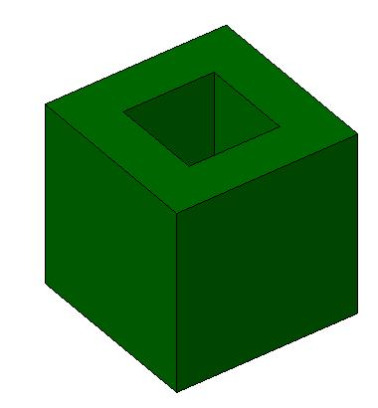
- Opening: Square.
- Walls: Four rectangular walls when the depression has vertical sides.
- Bottom: Square.
- Common example: A square recess in a cube.

Circular Surface-Depression Subtraction
# Source: AI Source: Provided by: [Data Path: Persons Table -> ID Column: 1, Name_En Column: Motasem Essam] -> From: [ChatGPT] on [7/25/2026]
Material is removed to create a circular recessed region.
- Opening: Circular.
- Walls: Usually cylindrical.
- Bottom: Circular.
- Common example: A wide circular recess in a solid block.

Triangular Surface-Depression Subtraction
# Source: AI Source: Provided by: [Data Path: Persons Table -> ID Column: 1, Name_En Column: Motasem Essam] -> From: [ChatGPT] on [7/25/2026]
Material is removed to create a triangular recessed region.
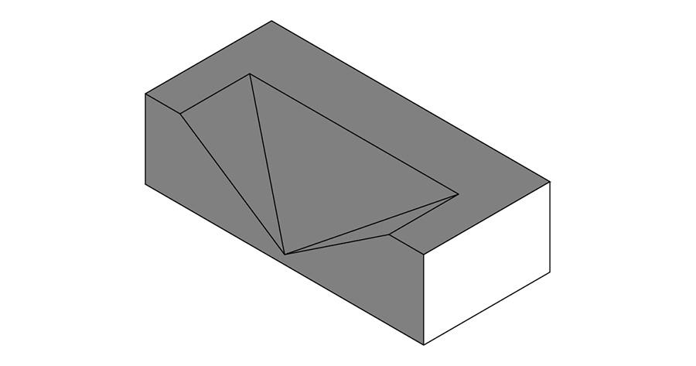
- Opening: Triangular.
- Walls: Usually three side walls.
- Bottom: Triangular.
- Common example: A triangular depression in a prism.

Polygonal Surface-Depression Subtraction
# Source: AI Source: Provided by: [Data Path: Persons Table -> ID Column: 1, Name_En Column: Motasem Essam] -> From: [ChatGPT] on [7/25/2026]
Material is removed to create a recessed region with a polygonal opening.
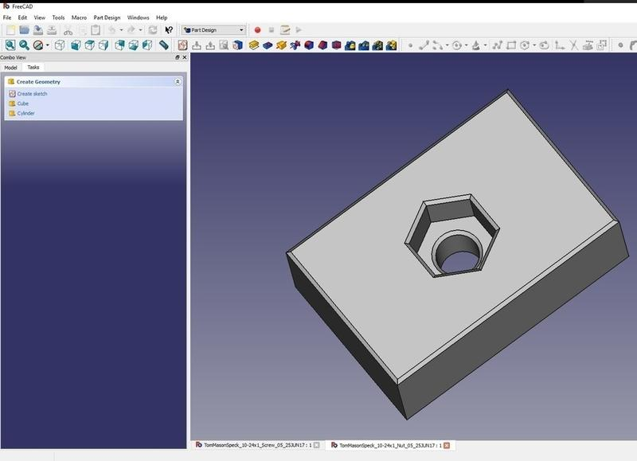
- Opening: Polygonal.
- Walls: Correspond to the sides of the polygon.
- Bottom: Polygonal.
- Common example: A hexagonal recess in a solid block.

Curved Surface-Depression Subtraction
# Source: AI Source: Provided by: [Data Path: Persons Table -> ID Column: 1, Name_En Column: Motasem Essam] -> From: [ChatGPT] on [7/25/2026]
Material is removed to create a depression with curved boundaries or curved internal surfaces.
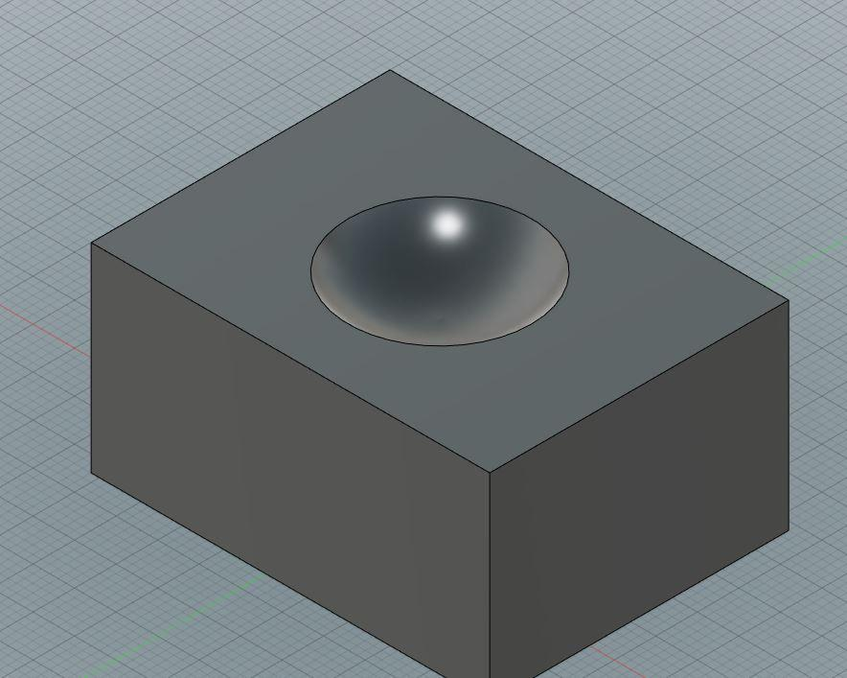
- Opening: Circular, elliptical, or irregularly curved.
- Walls: Curved.
- Bottom: May be flat or curved.
- Common example: A bowl-shaped depression in a solid.

Conical Surface-Depression Subtraction
# Source: AI Source: Provided by: [Data Path: Persons Table -> ID Column: 1, Name_En Column: Motasem Essam] -> From: [ChatGPT] on [7/25/2026]
Material is removed in the shape of a cone or conical section, creating a tapered depression.
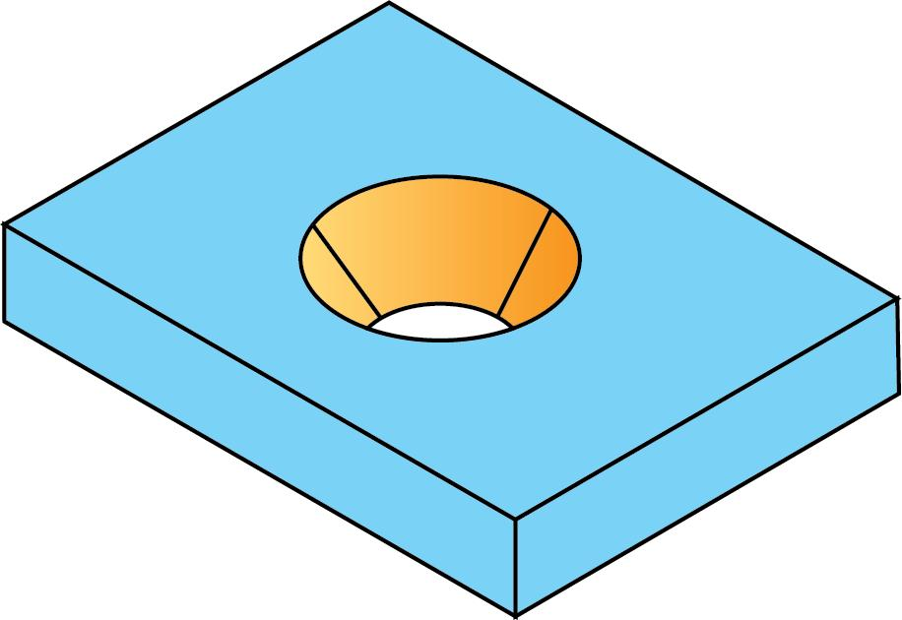
- Opening: Usually circular.
- Walls: Conical.
- Bottom: May terminate at a point or be truncated.
- Common example: A conical recess in a solid block.

Stepped Surface-Depression Subtraction
# Source: AI Source: Provided by: [Data Path: Persons Table -> ID Column: 1, Name_En Column: Motasem Essam] -> From: [ChatGPT] on [7/25/2026]
Material is removed at multiple depth levels to create a depression with steps.
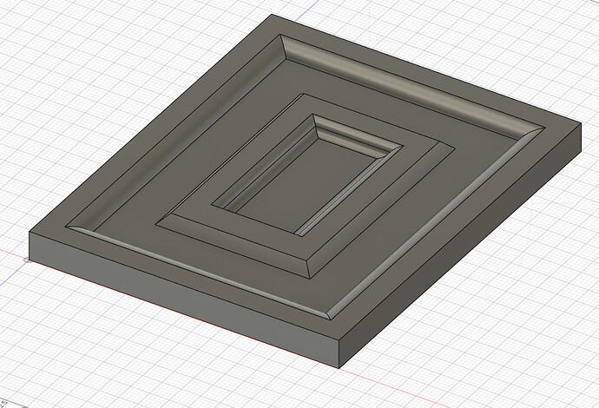
- Opening: Usually rectangular or polygonal.
- Walls: Multiple vertical or inclined sections.
- Bottom: Contains two or more levels.
- Common example: A two-level recessed pocket.

Irregular Surface-Depression Subtraction
# Source: AI Source: Provided by: [Data Path: Persons Table -> ID Column: 1, Name_En Column: Motasem Essam] -> From: [ChatGPT] on [7/25/2026]
Material is removed to create a depression with an irregular opening or boundary.
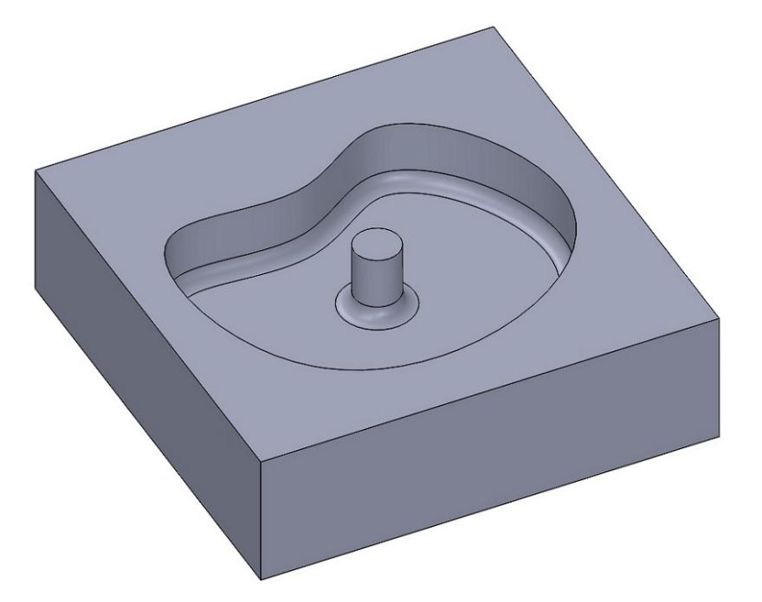
- Opening: Irregular.
- Walls: May be flat, curved, or mixed.
- Bottom: May be flat or irregular.
- Common example: An irregular recessed region in a rock-like solid.

Classification by Depression Depth
# Source: AI Source: Provided by: [Data Path: Persons Table -> ID Column: 1, Name_En Column: Motasem Essam] -> From: [ChatGPT] on [7/25/2026]
Surface depressions can also be classified according to their depth relative to the dimensions of the original solid.
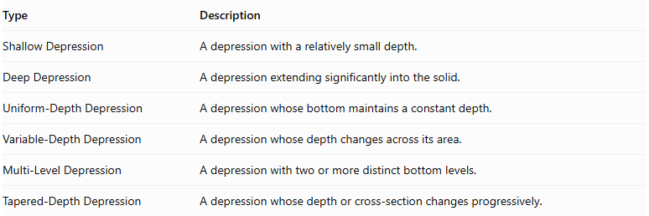
Type | Description
Shallow Depression | A depression with a relatively small depth.
Deep Depression | A depression extending significantly into the solid.
Uniform-Depth Depression | A depression whose bottom maintains a constant depth.
Variable-Depth Depression | A depression whose depth changes across its area.
Multi-Level Depression | A depression with two or more distinct bottom levels.
Tapered-Depth Depression | A depression whose depth or cross-section changes progressively.
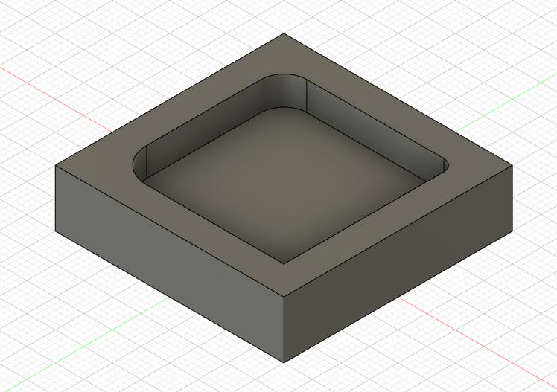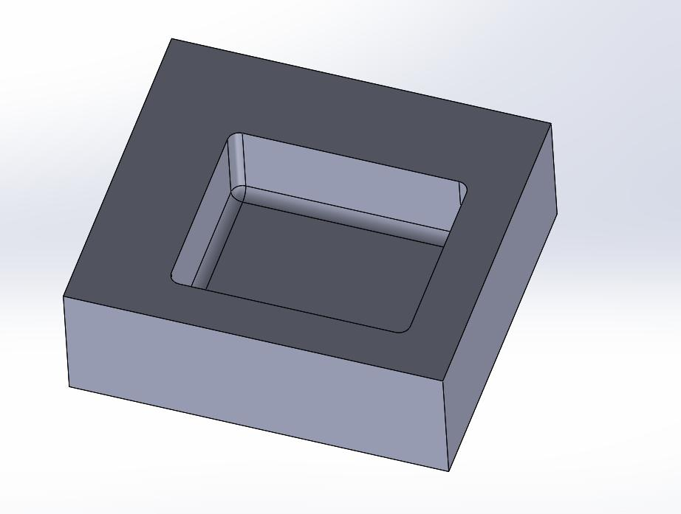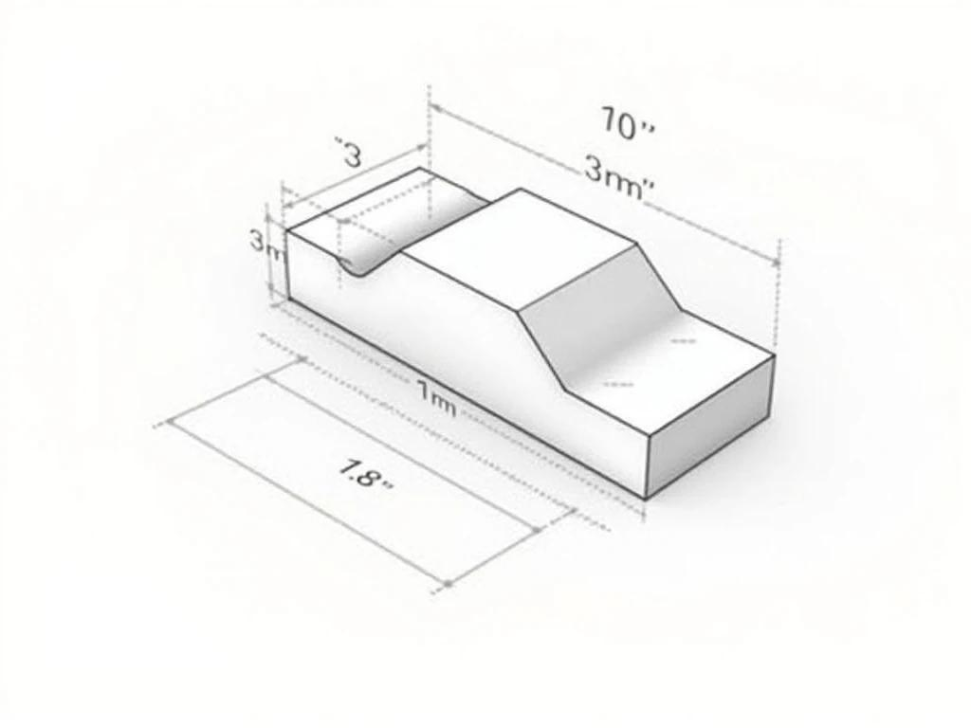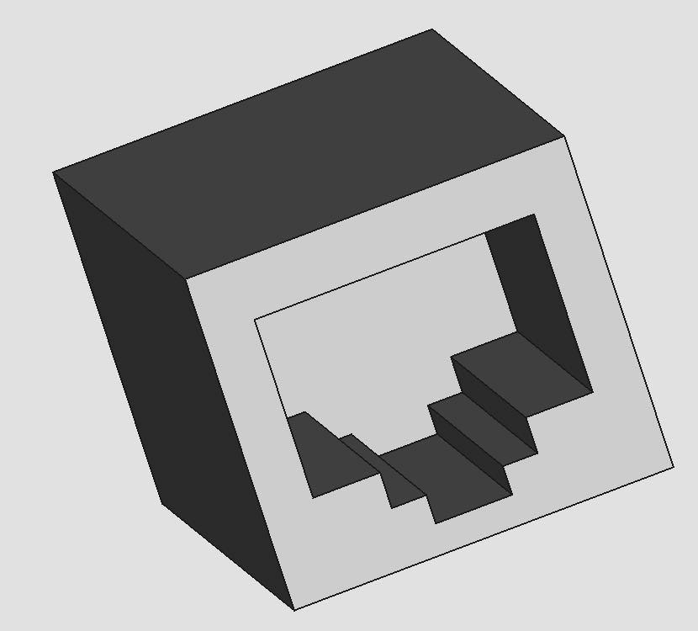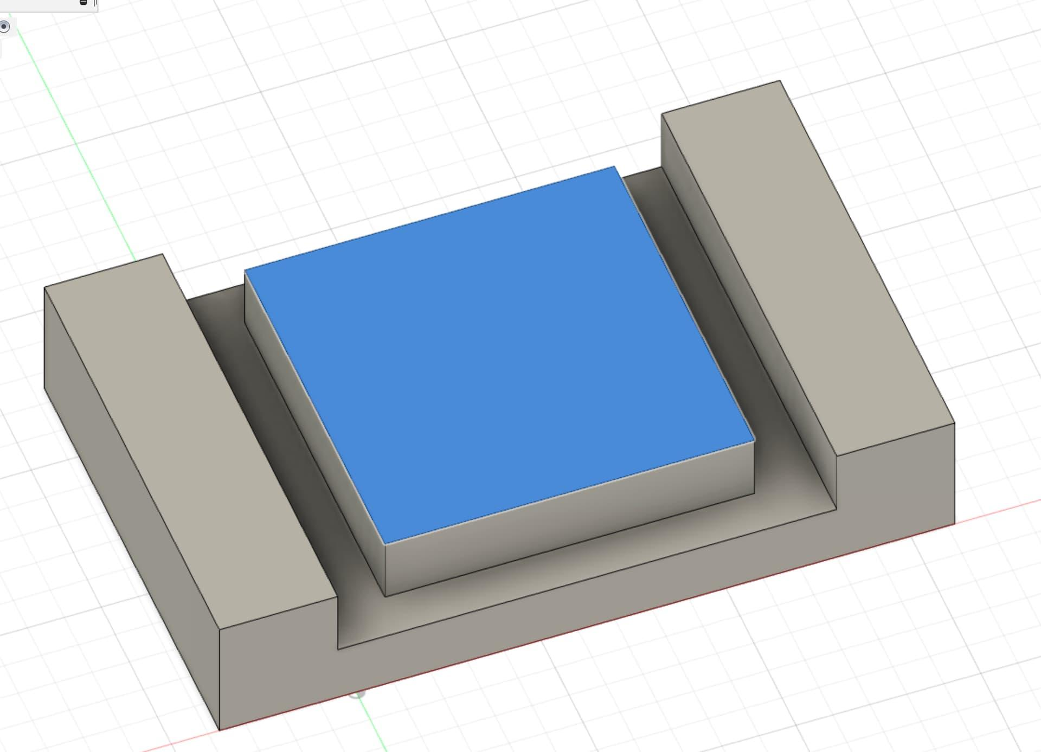

Classification by Opening Shape
# Source: AI Source: Provided by: [Data Path: Persons Table -> ID Column: 1, Name_En Column: Motasem Essam] -> From: [ChatGPT] on [7/25/2026]
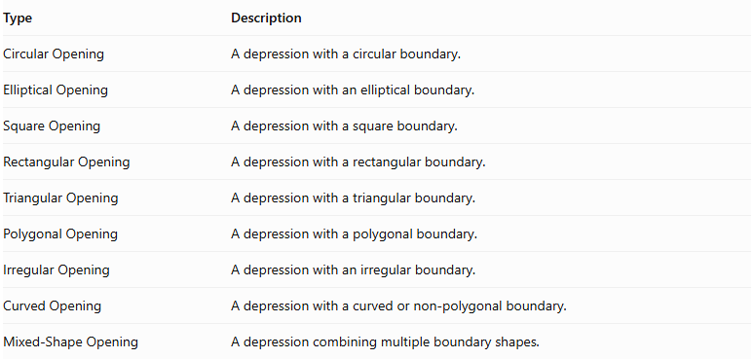
Type | Description
Circular Opening | A depression with a circular boundary.
Elliptical Opening | A depression with an elliptical boundary.
Square Opening | A depression with a square boundary.
Rectangular Opening | A depression with a rectangular boundary.
Triangular Opening | A depression with a triangular boundary.
Polygonal Opening | A depression with a polygonal boundary.
Irregular Opening | A depression with an irregular boundary.
Curved Opening | A depression with a curved or non-polygonal boundary.
Mixed-Shape Opening | A depression combining multiple boundary shapes.

Classification by Bottom Shape
# Source: AI Source: Provided by: [Data Path: Persons Table -> ID Column: 1, Name_En Column: Motasem Essam] -> From: [ChatGPT] on [7/25/2026]
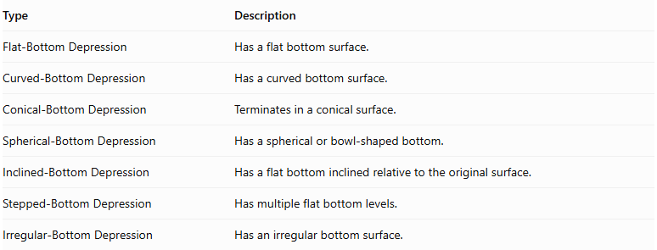
Type | Description
Flat-Bottom Depression | Has a flat bottom surface.
Curved-Bottom Depression | Has a curved bottom surface.
Conical-Bottom Depression | Terminates in a conical surface.
Spherical-Bottom Depression | Has a spherical or bowl-shaped bottom.
Inclined-Bottom Depression | Has a flat bottom inclined relative to the original surface.
Stepped-Bottom Depression | Has multiple flat bottom levels.
Irregular-Bottom Depression | Has an irregular bottom surface.

Classification by Arrangement
# Source: AI Source: Provided by: [Data Path: Persons Table -> ID Column: 1, Name_En Column: Motasem Essam] -> From: [ChatGPT] on [7/25/2026]
A solid may contain one or multiple depressions.
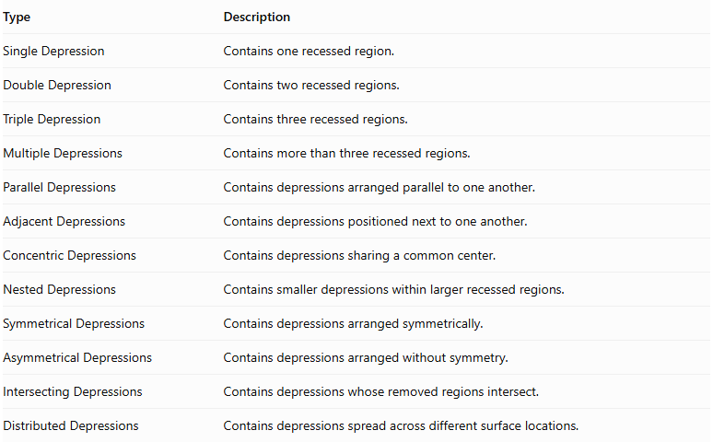
Type | Description
Single Depression | Contains one recessed region.
Double Depression | Contains two recessed regions.
Triple Depression | Contains three recessed regions.
Multiple Depressions | Contains more than three recessed regions.
Parallel Depressions | Contains depressions arranged parallel to one another.
Adjacent Depressions | Contains depressions positioned next to one another.
Concentric Depressions | Contains depressions sharing a common center.
Nested Depressions | Contains smaller depressions within larger recessed regions.
Symmetrical Depressions | Contains depressions arranged symmetrically.
Asymmetrical Depressions | Contains depressions arranged without symmetry.
Intersecting Depressions | Contains depressions whose removed regions intersect.
Distributed Depressions | Contains depressions spread across different surface locations.
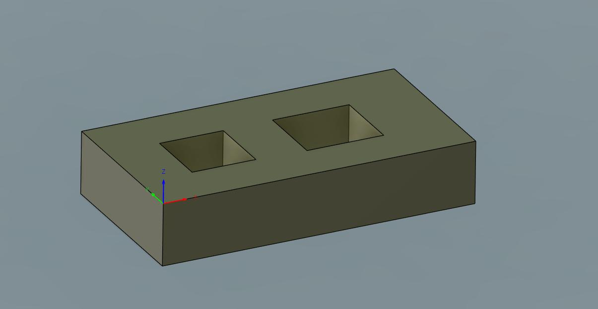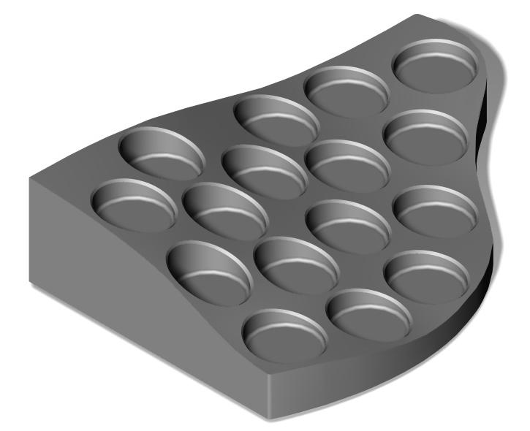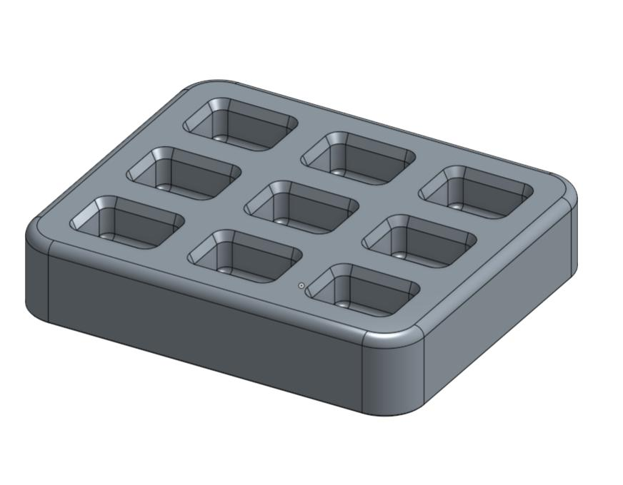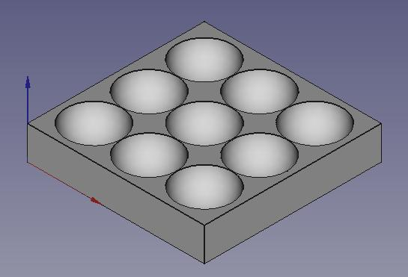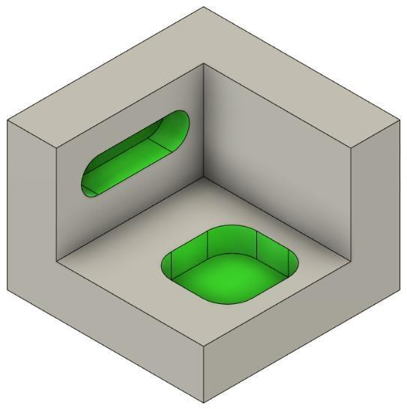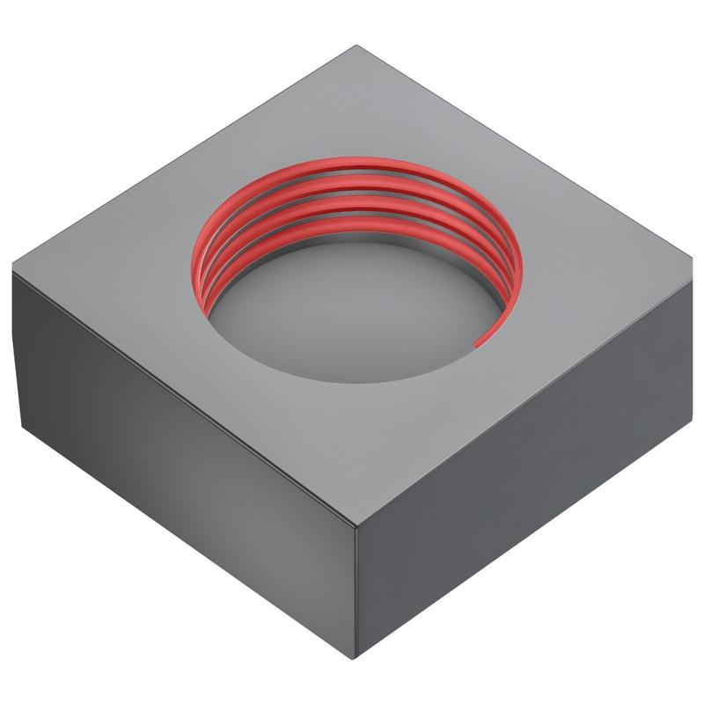

Mathematical Properties and Formulas

Remaining Volume
# Source: AI Source: Provided by: [Data Path: Persons Table -> ID Column: 1, Name_En Column: Motasem Essam] -> From: [ChatGPT] on [7/25/2026]
The remaining volume is calculated by subtracting the volume of the depression from the original solid's volume.
$$\boxed{V_{r}=V_{o}-V_{d}}$$
Where:
- $V_{r}$ = Remaining volume.
- $V_{o}$ = Original solid volume.
- $V_{d}$ = Removed depression volume.
For multiple non-overlapping depressions:
$$V_{r}=V_{o}-\sum_{i=1}^{n}{V_{d_{i}}}$$
If removed regions overlap, their common volume must not be counted more than once.

Common Depression Volume Formulas
# Source: AI Source: Provided by: [Data Path: Persons Table -> ID Column: 1, Name_En Column: Motasem Essam] -> From: [ChatGPT] on [7/25/2026]
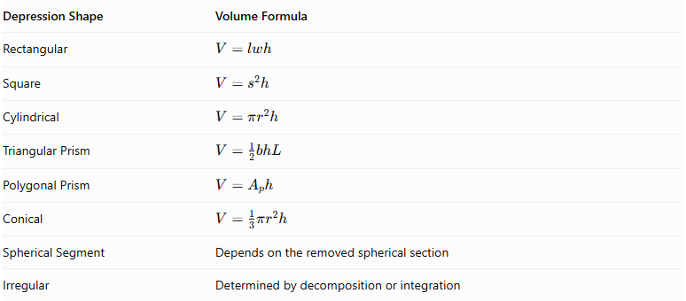
Depression Shape | Volume Formula
Rectangular | $$V=lwh$$
Square | $$V=s^{2}h$$
Cylindrical | $$V=πr^{2}h$$
Triangular Prism | $$V=\frac{1}{2}bhL$$
Polygonal Prism | $$V=A_{ph}$$
Conical | $$V=\frac{1}{3}πr^{2}h$$
Spherical Segment | Depends on the removed spherical section
Irregular | Determined by decomposition or integration
Where:
- $l$ = Length of the depression.
- $w$ = Width of the depression.
- $s$ = Side length of a square opening.
- $r$ = Radius of a circular opening.
- $h$ = Depression depth.
- $b$ = Triangle base.
- $L$ = Length of a triangular-prism depression.
- $A_{p}$ = Area of the polygonal cross-section.

Surface Area
# Source: AI Source: Provided by: [Data Path: Persons Table -> ID Column: 1, Name_En Column: Motasem Essam] -> From: [ChatGPT] on [7/25/2026]
Surface area requires special attention because removing material changes the original external surface.
For a depression with a flat opening and a flat bottom:
$$\boxed{{SA}_{r}={SA}_{o}-A_{opening}+A_{bottom}+A_{walls}}$$
Where:
- ${SA}_{r}$ = Remaining external surface area.
- ${SA}_{o}$ = Original external surface area.
- $A_{opening}$ = Original surface area removed at the opening.
- $A_{bottom}$ = Newly exposed bottom area.
- $A_{walls}$ = Newly exposed internal wall area.
For a vertical-sided rectangular depression:
$$A_{walls}=2lh+2wh$$
Therefore:
$${SA}_{r}={SA}_{o}-lw+lw+2lh+2wh$$
$$\boxed{{SA}_{r}={SA}_{o}+2h(l+w)}$$
This formula assumes the rectangular depression is fully contained within a flat surface, has vertical walls, and has a flat bottom.
For a cylindrical depression with a flat bottom:
$$A_{walls}=2πrh$$
Since the circular opening and bottom have equal areas:
$$\boxed{{SA}_{r}={SA}_{o}+2πrh}$$
These formulas do not automatically apply to tapered, curved, intersecting, or irregular depressions.

Worked Examples

Example 1: Rectangular Surface-Depression Subtraction
# Source: AI Source: Provided by: [Data Path: Persons Table -> ID Column: 1, Name_En Column: Motasem Essam] -> From: [ChatGPT] on [7/25/2026]
A rectangular prism has dimensions:
- Length = 12 cm
- Width = 8 cm
- Height = 6 cm
A rectangular depression is cut into its top surface with:
- Length = 4 cm
- Width = 3 cm
- Depth = 2 cm
Find the remaining volume and surface area.
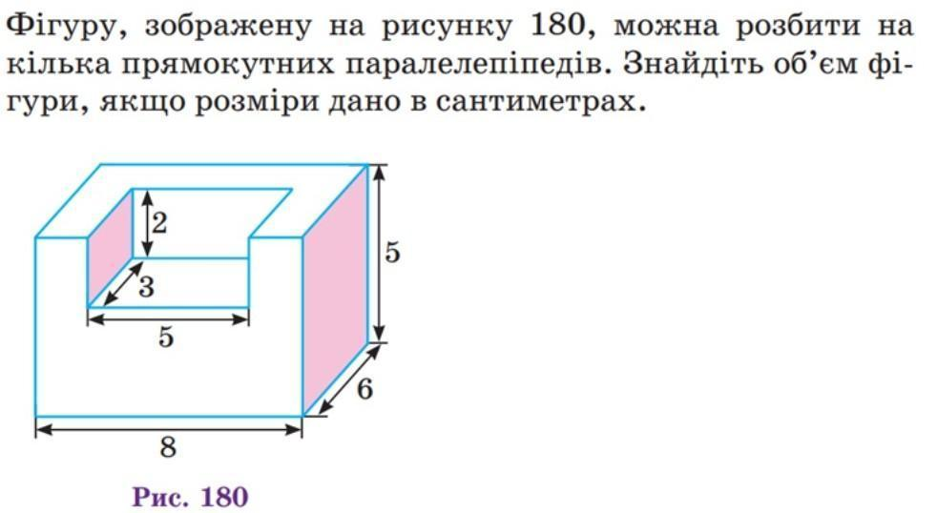
Step 1: Calculate the original volume.
$$V_{o}=12×8×6$$
$$V_{o}=576{ cm}^{3}$$
Step 2: Calculate the removed volume.
$$V_{d}=4×3×2$$
$$V_{d}=24{ cm}^{3}$$
Step 3: Calculate the remaining volume.
$$V_{r}=576-24$$
$$\boxed{V_{r}=552{ cm}^{3}}$$
Step 4: Calculate the original surface area.
$${SA}_{o}=2(lw+lh+wh)$$
$$=2(96+72+48)$$
$${SA}_{o}=432{ cm}^{2}$$
Step 5: Calculate the remaining surface area.
The opening area removed equals the bottom area added:
$$A_{opening}=4×3=12$$
$$A_{bottom}=12$$
The four internal walls have area:
$$A_{walls}=2(4×2)+2(3×2)$$
$$=16+12=28{ cm}^{2}$$
Therefore:
$${SA}_{r}=432-12+12+28$$
$$\boxed{{SA}_{r}=460{ cm}^{2}}$$
Final Answer:
- Remaining Volume = 552 cm³
- Remaining Surface Area = 460 cm²

Example 2: Circular Surface-Depression Subtraction
# Source: AI Source: Provided by: [Data Path: Persons Table -> ID Column: 1, Name_En Column: Motasem Essam] -> From: [ChatGPT] on [7/25/2026]
A cube has a side length of 10 cm. A cylindrical depression is cut into its top surface with:
- Radius = 2 cm
- Depth = 3 cm
Find the remaining volume and surface area.
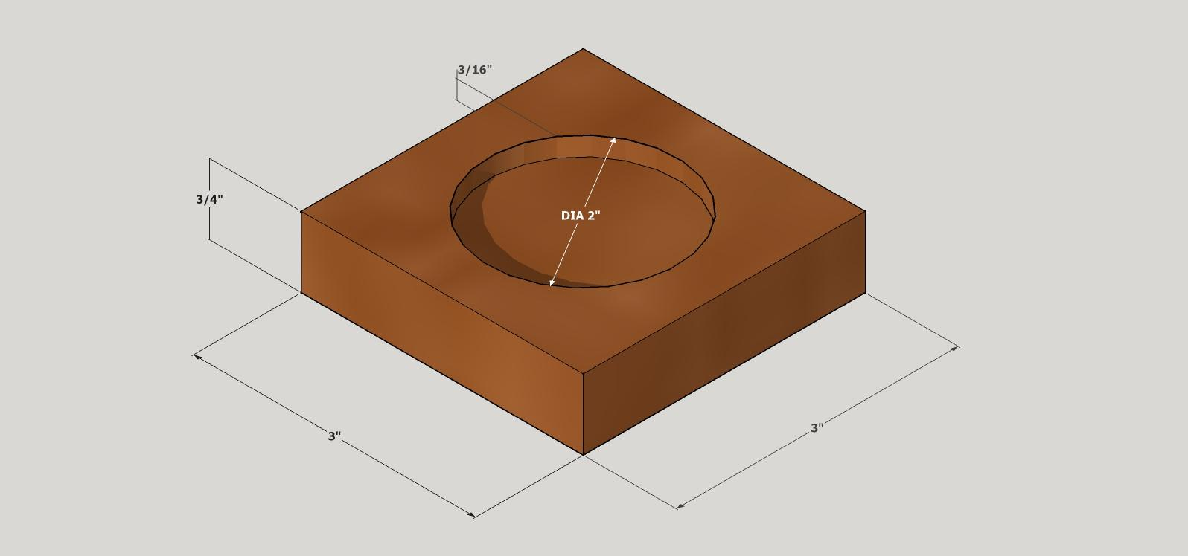
Step 1: Calculate the original volume.
$$V_{o}={10}^{3}=1000{ cm}^{3}$$
Step 2: Calculate the removed cylindrical volume.
$$V_{d}=πr^{2}h$$
$$=π(2)^{2}(3)$$
$$V_{d}=12π{ cm}^{3}$$
Step 3: Calculate the remaining volume.
$$V_{r}=1000-12π$$
$$\boxed{V_{r}≈962.30{ cm}^{3}}$$
Step 4: Calculate the original surface area.
$${SA}_{o}=6({10}^{2})=600{ cm}^{2}$$
Step 5: Calculate the remaining surface area.
The circular opening and flat bottom have equal areas, so they cancel each other.
The newly exposed cylindrical wall area is:
$$A_{walls}=2πrh$$
$$=2π(2)(3)=12π$$
Therefore:
$${SA}_{r}=600+12π$$
$$\boxed{{SA}_{r}≈637.70{ cm}^{2}}$$
Final Answer:
- Remaining Volume = 962.30 cm³
- Remaining Surface Area = 637.70 cm²

Important Characteristics
# Source: AI Source: Provided by: [Data Path: Persons Table -> ID Column: 1, Name_En Column: Motasem Essam] -> From: [ChatGPT] on [7/25/2026]
- Material is removed from an existing solid's outer surface.
- The resulting solid contains one or more recessed regions.
- A depression does not normally extend completely through the original solid.
- The depression may have flat, curved, inclined, or stepped walls.
- The bottom may be flat, curved, conical, or irregular.
- The opening may have different geometric shapes.
- Multiple depressions can be arranged symmetrically or asymmetrically.
- The remaining volume is smaller than the original volume.
- Surface area may increase or decrease depending on the geometry of the depression.
- The depression depth must remain within the original solid if the resulting feature is to remain a depression rather than become a through-hole.

Comparison with Other Subtraction Methods
# Source: AI Source: Provided by: [Data Path: Persons Table -> ID Column: 1, Name_En Column: Motasem Essam] -> From: [ChatGPT] on [7/25/2026]
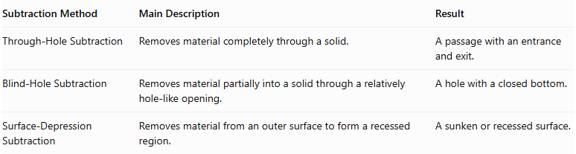
Subtraction Method | Main Description | Result
Through-Hole Subtraction | Removes material completely through a solid. | A passage with an entrance and exit.
Blind-Hole Subtraction | Removes material partially into a solid through a relatively hole-like opening. | A hole with a closed bottom.
Surface-Depression Subtraction | Removes material from an outer surface to form a recessed region. | A sunken or recessed surface.
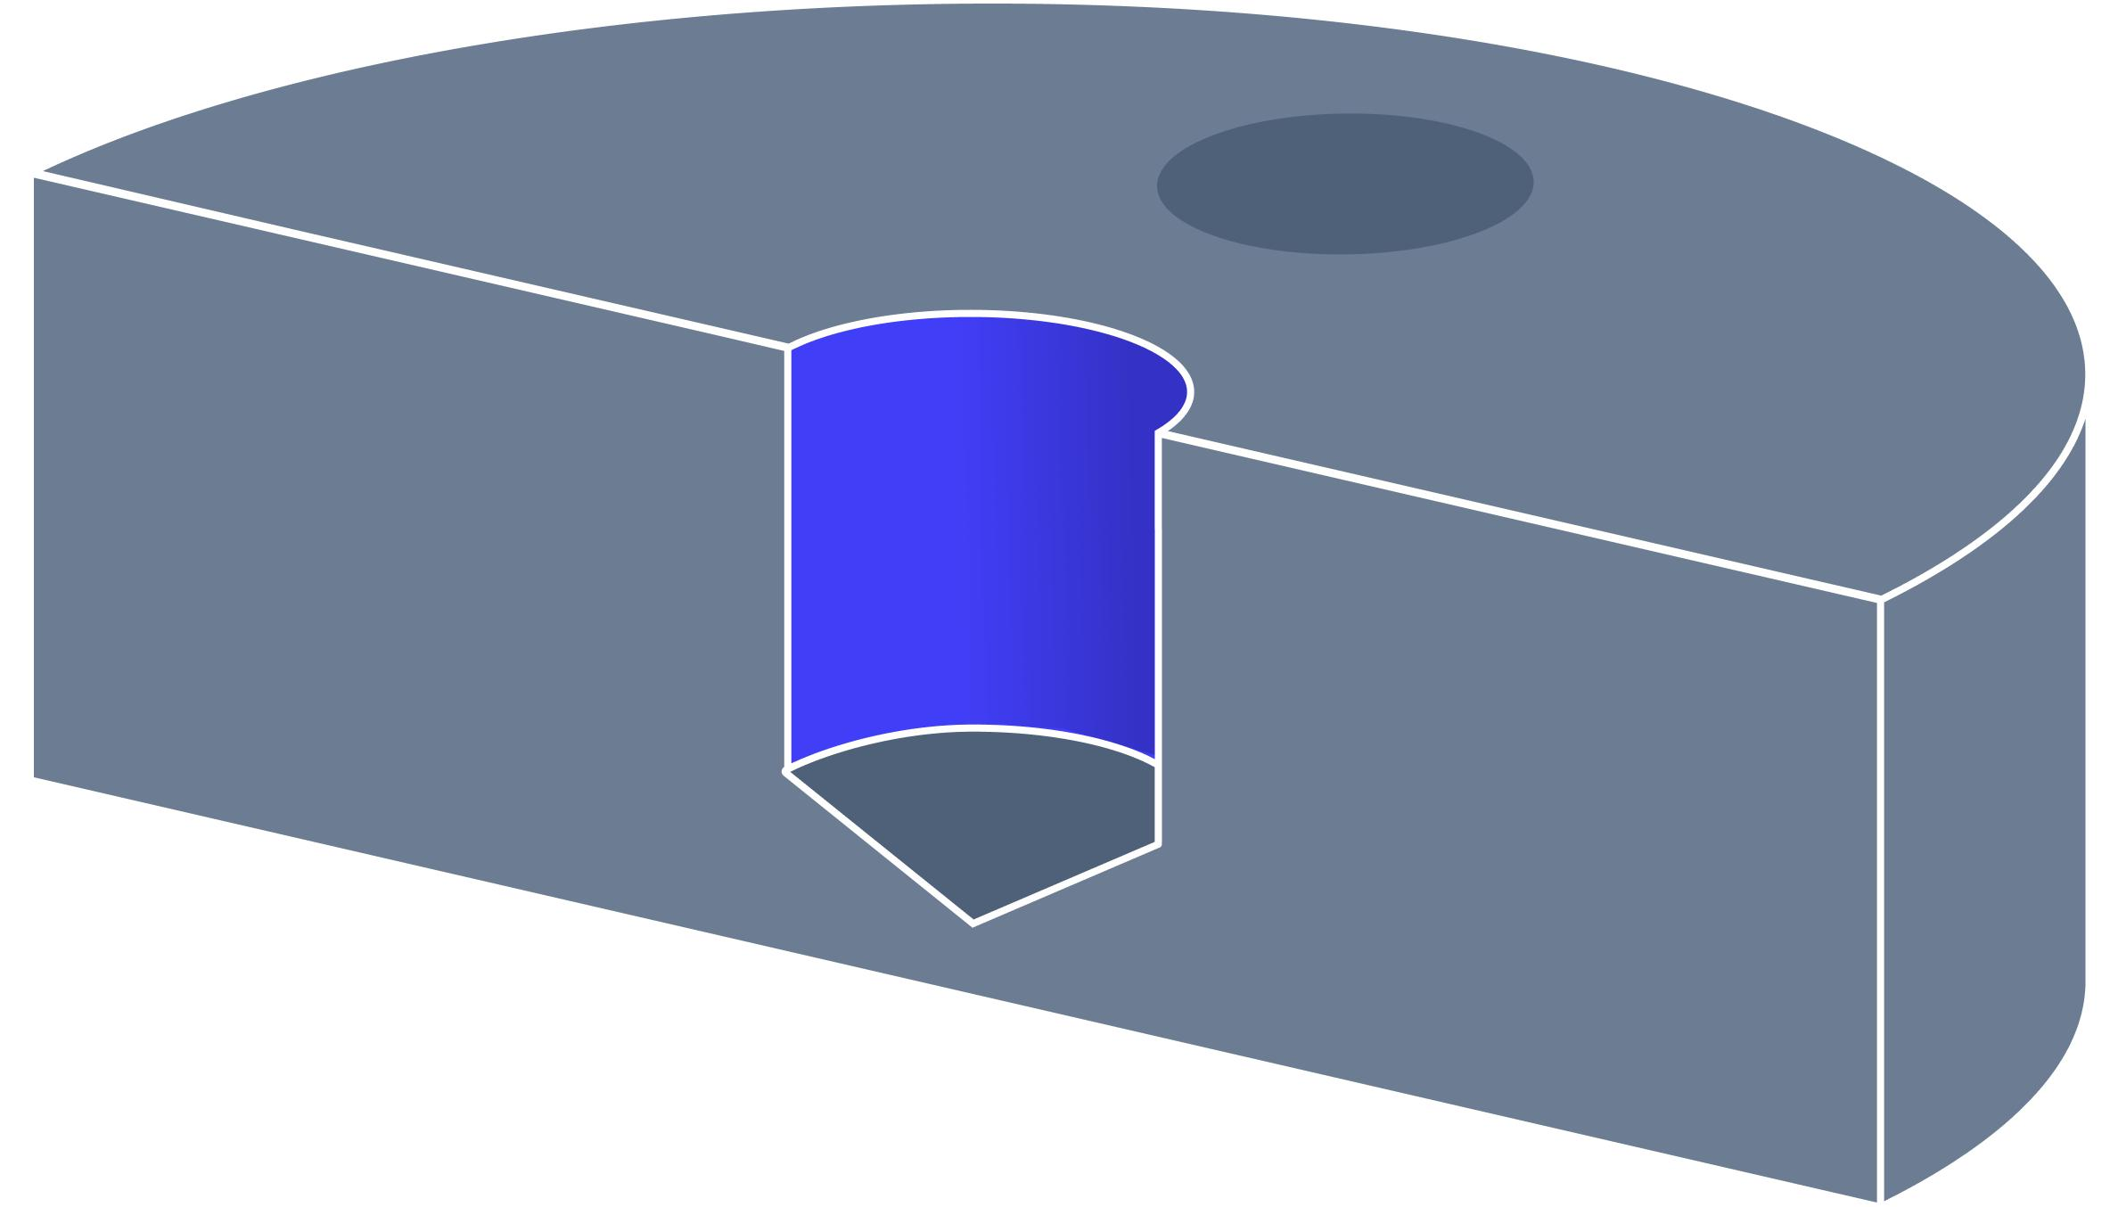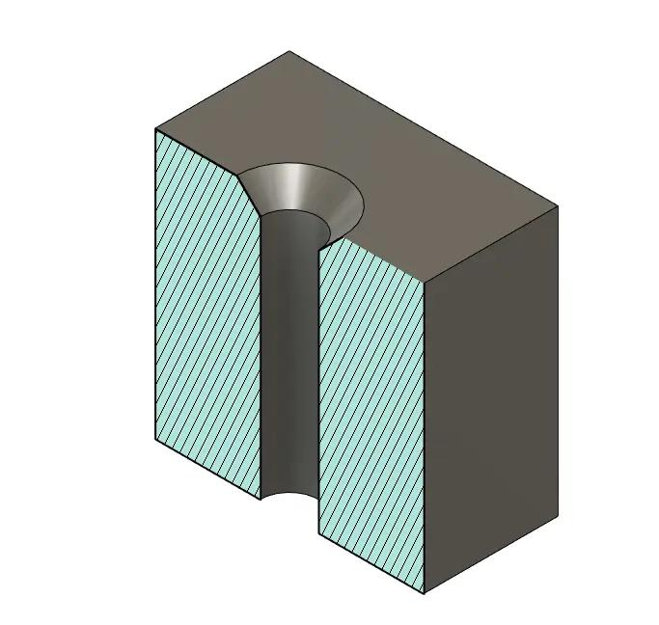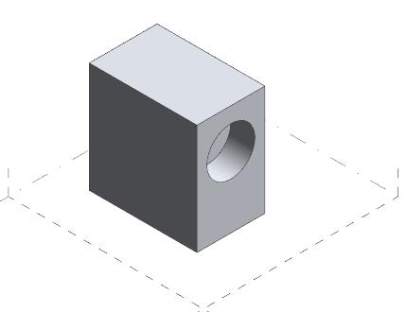
Important distinction: A blind hole is a particular type of partially penetrating hole, while a surface depression is a broader recessed surface feature. A wide, shallow rectangular pocket is a surface depression, whereas a narrow cylindrical hole with a closed bottom is generally classified as a blind hole.

Applications
# Source: AI Source: Provided by: [Data Path: Persons Table -> ID Column: 1, Name_En Column: Motasem Essam] -> From: [ChatGPT] on [7/25/2026]
Surface-depression subtraction is commonly used in:
- Mechanical engineering: recessed mounting areas and component seats.
- Manufacturing: machined pockets and recessed surfaces.
- Architecture: decorative wall and floor recesses.
- Product design: recessed buttons and control panels.
- Construction: grooves and recessed structural details.
- Furniture design: inset panels and recessed handles.
- Packaging: molded trays and product compartments.
- Industrial design: stepped recesses and component housings.

Key Points
# Source: AI Source: Provided by: [Data Path: Persons Table -> ID Column: 1, Name_En Column: Motasem Essam] -> From: [ChatGPT] on [7/25/2026]
- Surface-depression subtraction creates a recessed region by removing material from an existing solid.
- It can produce rectangular, square, circular, triangular, polygonal, curved, conical, stepped, or irregular depressions.
- Depressions can be classified by opening shape, depth, bottom shape, and arrangement.
- The remaining volume is the original volume minus the removed volume, with overlap corrections when necessary.
- Surface-area calculations must exclude the removed opening and include newly exposed bottom and wall surfaces.
- A surface depression is different from a through-hole and is broader than a conventional blind hole.

Conclusion
# Source: AI Source: Provided by: [Data Path: Persons Table -> ID Column: 1, Name_En Column: Motasem Essam] -> From: [ChatGPT] on [7/25/2026]
Surface-Depression Subtraction is an important classification of composite solids formed by subtraction. It involves removing material from an outer surface to produce recessed geometric regions without necessarily creating a passage through the solid.
Its classification depends on the shape of the opening, depth, bottom geometry, and arrangement of the depressions. Understanding these properties makes it possible to calculate the remaining volume and external surface area accurately and to distinguish surface depressions from other subtraction methods.

